Krazy Karel

An endless side-scroller game where karel must move up or down to avoid obstacles.

Anderson Moffitt and Aaryan Dave

Period 7

**Activity Log:**

May 7th – Thought of ideas for our final project, and finalized on Krazy Karel, a spin off of the Cool math games game Crazy Taxi. We pitched our idea to Mr. Tra, who approved. We then set up our GitHub project to export our files to.

Possible Problems:

* User tries going off screen
* Game may not be smooth

GUI from Player View:

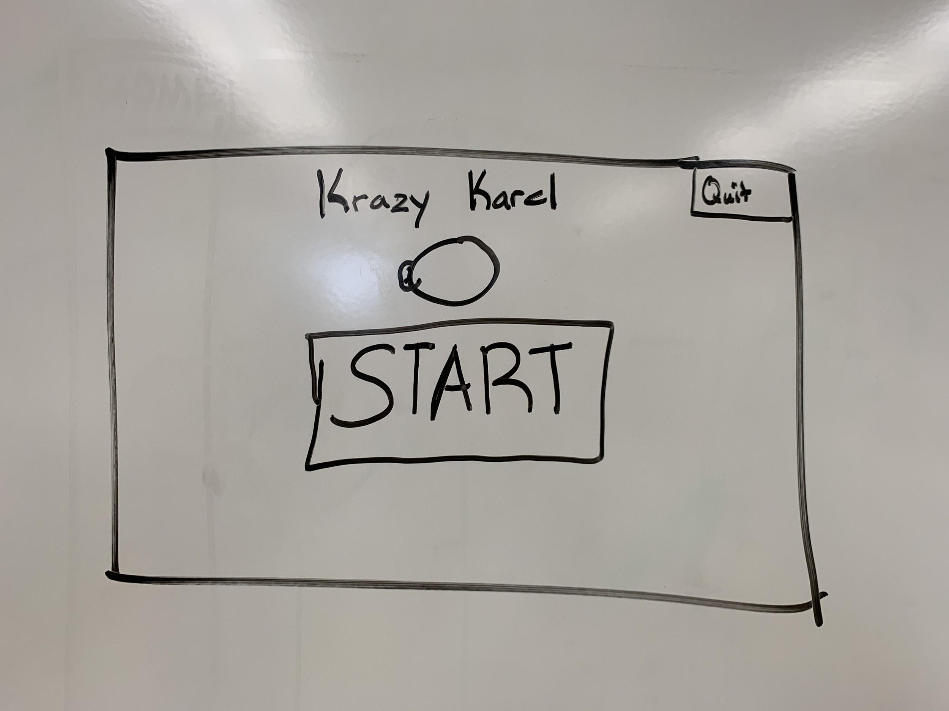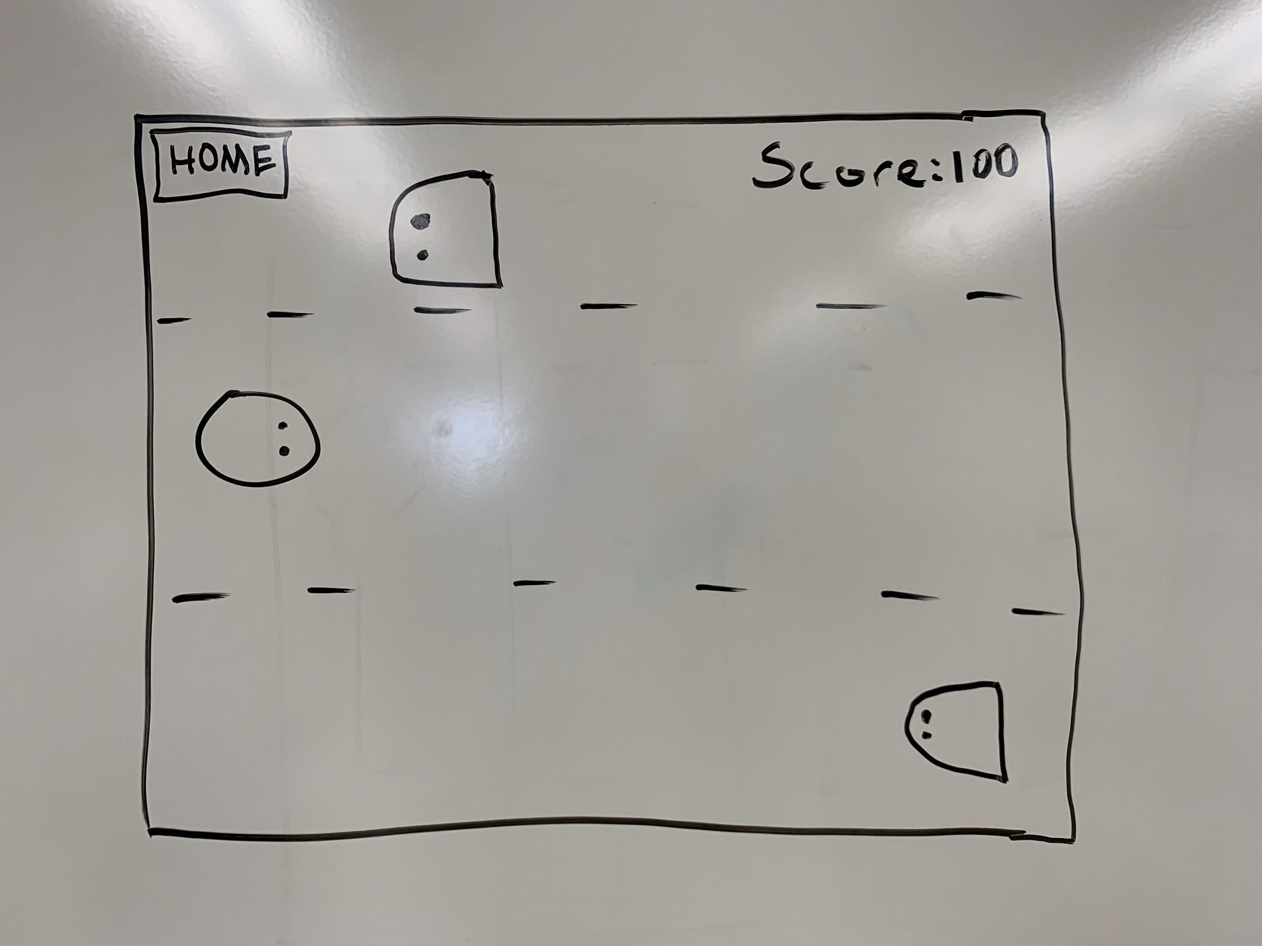

Classes:

* Karel Class
* Homepage Class
* Player Class
* Individual Avatar Classes
* Blocker Class
* Background Class

Description of Gameplay:

The player will use the up and down arrow keys to control Karel. The player main goal is to prevent the Karel runner from running into a Karel blocker. The blockers will spawn in 1 of the 3 lanes. As the user progresses through the game by avoiding the blockers, the runner’s pace and blocker drop speed will increase.

Partner Distribution:

Both partners will work on all parts of the project, but we will each lead our own parts.

Aaryan:

* Blocker Class
* Avatar Class
* Player Class

Anderson:

* Background Graphics
* Homepage Class
* Background Class
* Rest of Graphics